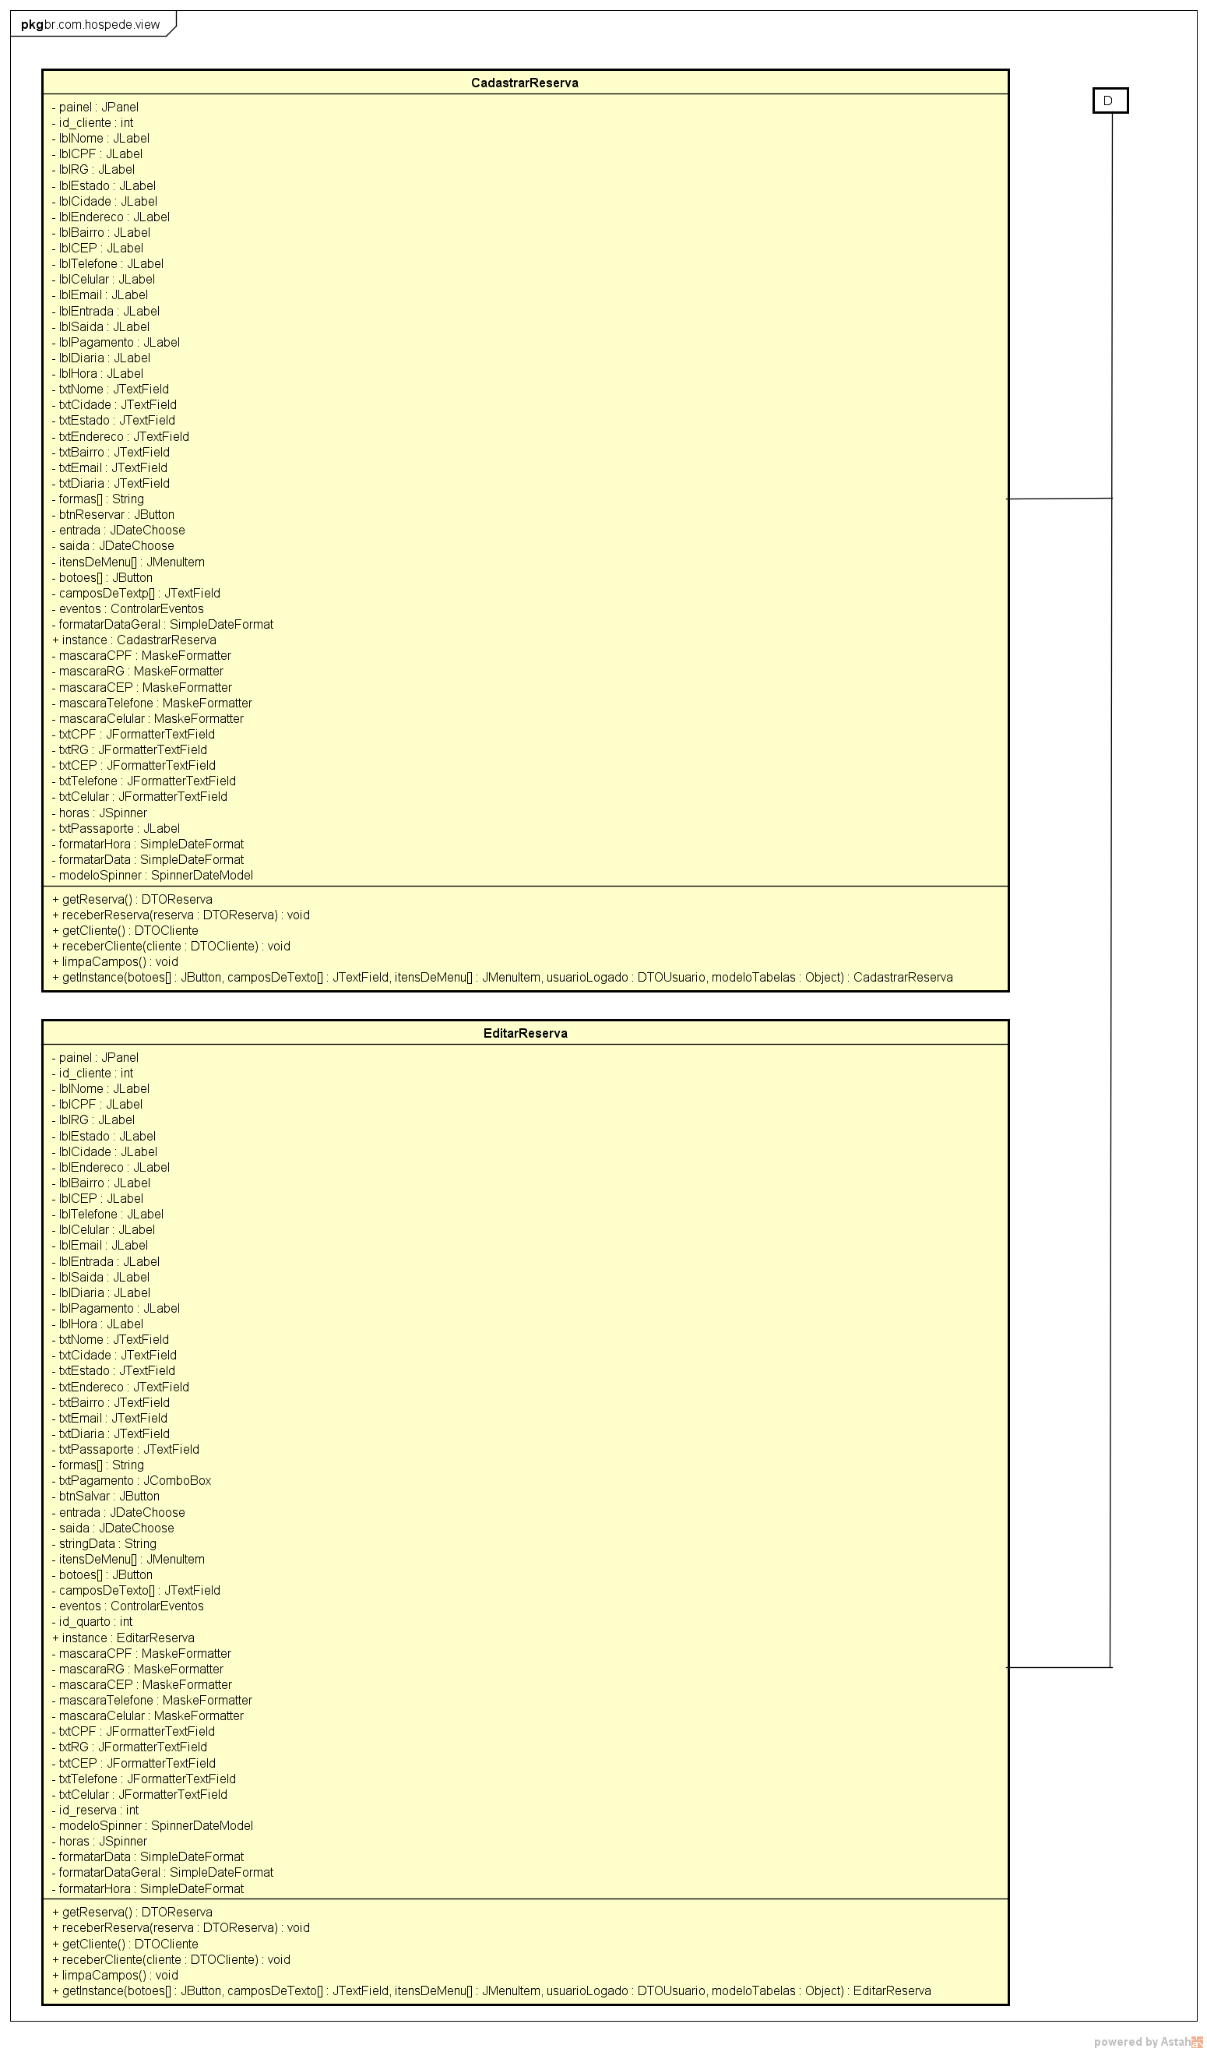

**Figura 9** – Diagrama de Classes Camada view D

57